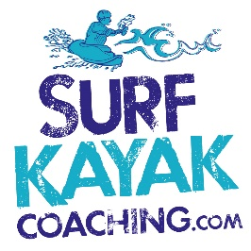
Course Booking Form

Name: ……………………………………………………………………………………………………

Date of Birth: …………………………………………………………………………………………

Mobile number: …………………………………………………………………………………

Email: ……………………………………………………………………………………………………

Course name: ……………………………………………………………………………………….

Course date: …………………….................

Medical information (please list any allergies, epilepsy, and existing conditions):

……………………………………………………………………………………………………………………………………………………………………
……………………………………………………………………………………………………………………………………………………………………
Participation Statement
I understand that any photographs or video taken on the course may be used in social media and for marketing purposes. (Delete if you disagree)
I understand that this course may require me to take part in continuous, moderate exercise for several hours. I believe that I am capable of this, taking the factors I have stated above into consideration.
I accept that adventure sports contain an element of real risk and whilst Surf Kayak Coaching will take all necessary precautions to reduce risk, they cannot eliminate all these risks without undermining the adventure experience or the reason for taking part. We will follow the instructor’s safety instructions closely and accept the risks involved.
Signed ……………………………………………………………………………………… Date ……………………………
□ I have checked the information on the booking form.
□ I have read, understood and accept the Terms and Conditions of this booking.
□ I will inform Surf Kayak Coaching of any changes to the above in writing.

Completed forms to annette@surfkayakcoaching.com or post to:
Surf Kayak Coaching, 6 Bodriggy Villas, Hayle, Cornwall, TR27 4PG

